CMP9135M Applying Computer Vision techniques for feature extraction and texture analysis on skin Lesions



line 1: 2nd Stephen Rerri-Bekibele  
line 2: *School of Computer Science. University of Lincoln   
(of Affiliation)*line 3: Lincoln, United Kingdom  
line 4: 16663359@students.lincoln.ac.uk

Table of Contents

Introduction 2

Concept 2

Evaluation 3

Appendix 5

*Abstract*— The accurate and clear detection of diseases or abnormalities is very necessary and relevant in modern problems ranging from Medical to vehicle automation. This report tackles the problems of Image segmentation, Feature Calculation and Object tracking in 3 different scenarios. 1. The detection and segmentation of skin lesions. 2. Feature calculation of a given image. 3. Object tracking and plotting of a moving target according to a generic frame to frame image segmentation of a target.

Keywords—Feature Calculation, Medical, skin lesions, image segmentation, object tracking, detection (key words)

# Introduction

## TASK 1 Image Segmentation and Detection

To segment lesions from images a few steps have to be taken.

Two methods were devised to increase the effective ness of the object segmentation. If a sample had a higher score in either method that score was taken instead. This meant that where one method failed to get an accurate segmentation of an object, the other got a significantly better segmentation. The methods largely had the same steps but differed in a few key places.

Both methods were created in a function called compute dice score which took in each image and enhanced them by mapping the intensity values to a new output variable by saturating the top 1% and bottom 1% of all the pixel values effectively increasing the contrast of the output image.

In method 1 K-means clustering was then used to separate the image into three different clusters, this partially segmented the lesions from the skin after which the erode function was used with a flat structuring element of shape ball to remove some of the unnecessary spots from the image. At this stage the image was finally converted to grey and binarized. The edges of the image were then detected and specks touching the borders of the image were removed before any remaining small blobs were erased. The remaining hole was filled in and the resulting image could then be compared against the ground truth.

The method 2 method used the same method as the first but skipped the k-means classification step and instead went on to converting the image to grayscale after enhancing it. In this method the grey images were then inverted because the grayscale image when binarized already had a clear outline of the lesion. This inversion made the holes the lesion instead of the background and vice versa.

In the same way as above, any specks that were touching the image boarder were now removed, blobs were removed and the newly created “lesion holes” from inverting the image were filled in.

Testing showed that doing these actions in this order helped to make images that had poor lesion detection at the end of the method 1, come out much better in method 2 and result in a better lesion detection. The addition of method 2 raised the lesion detection accuracy from 59% to 80%.

## Task 2 Feature Calculation

For this task the frequency domain of the image was calculated and displayed at different angles to see how the angles and directions affected the resulting image.

The resulting Fourier domain showed each point representing a particular frequency contained in the spatial domain image. To analyse the textures in the image the frequency domain had to be observed.

The image was converted to the Fourier domain in order to find the spectral features. To calculate the feature for various radiuses the equation below was implemented:

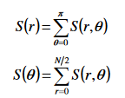

The various radiuses used were plotted in a graph and the various angles from 0-360 were also plotted in a separate graph. To view the effect of changing the radius simply pick a choice of radius in the radius_values index by picking a value between 1 and 7.

To express the spatial domain in polar coordinates we get the new coordinates of the image by dividing the image in two and multiplying the radius by the sin of each angle for the height of the image and radius by cos each angle for the width of the image and then compute the Fourier transform of the polar coordinates for S_r_theta.

With the Fourier transform we can now calculate S_r values for each radius and S_theta for each angles. S_r is calculated as the sum of all the pixels in the Fourier transform at the given radius. S_theta is calculated as the sum of all the pixels Fourier transform at angle theta. Results showed that as the radius increased, the number of features decreased therefore the number of features is inversely proportional to the size of the radius.

This means there is a negative correlation between the radius size and number of features.

To select features for calculation from the co-occurance matrix and grey level run length matrix two funcions were written.

For the gray co-currence matrix the image was first converted to grayscale and then a histogram is calculated for all the gray levels of the image. From the histogram the statistics such as mean, variance, skewness, kurtosis, energy and lastly entropy are all calculated.

The results showed that the mean value for the probability density of occurrence of the intensity of the image was ~4.

To extract the texture features the Gray Level Run Length matrix was implemented by converting the image to grayscale, providing a quantize value and a binary mask of the image to use with values of 1 at the region of interest.

Next the range of the image was calculated by retrieving the min and max pixel values of the image and then the image was quantized to discrete integer values between 1 and the set quantize value. Four different degree angles, 0,45,90 and 135 were then tested and the pixels for each quantization level were recorded.

To finish off, the features for the four angles were calculated. The results showed that in all cases only GLN, RLN and HGRE were read.

With a quantization level of 4 RLN was the lowest value and GLN and HGRE were joint first. When a quantization level of 6 was tested, all 3 values increased but RLN was still the lowest and HGRE and GLN were joint first yet again. Lastly, when a quantization level of 8 was chosen however, RLN was the highest value with GLN and HGRE coming in joint second.

## Task 3 Object Tracking

Task 3 involved displaying the trajectory of a tracked image according to its pixel positions. Two graphs were plotted and compared. One was the real coordinates of the moving target and the second was the estimated trajectory from a noisy equivalent provided by a generic video detector. The mean, standard deviation of the absolute mean error and the root mean squared error were calculated

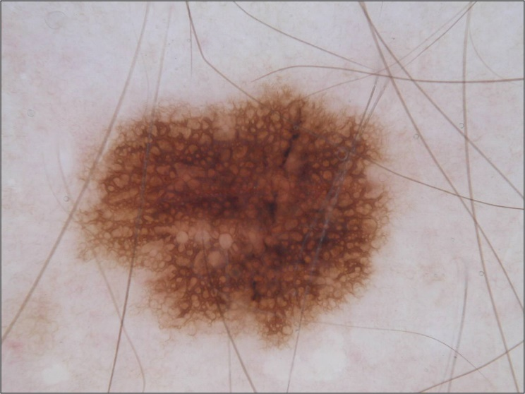

ISIC_19 DICE_SCORE 0.8678 (number 4) 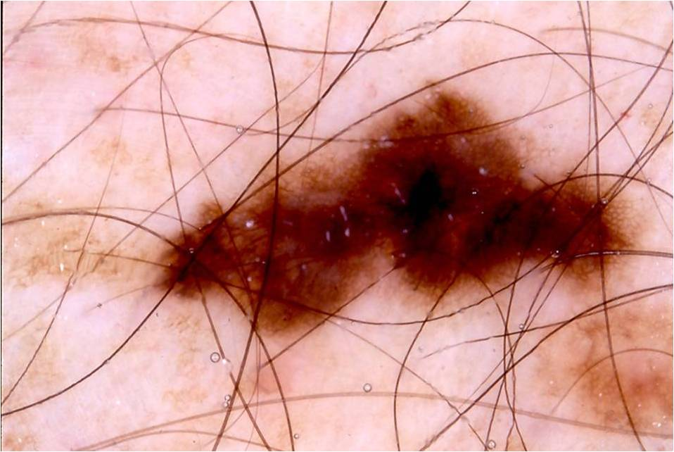

ISIC_214 DICE_SCORE 0.8525 (number 58)

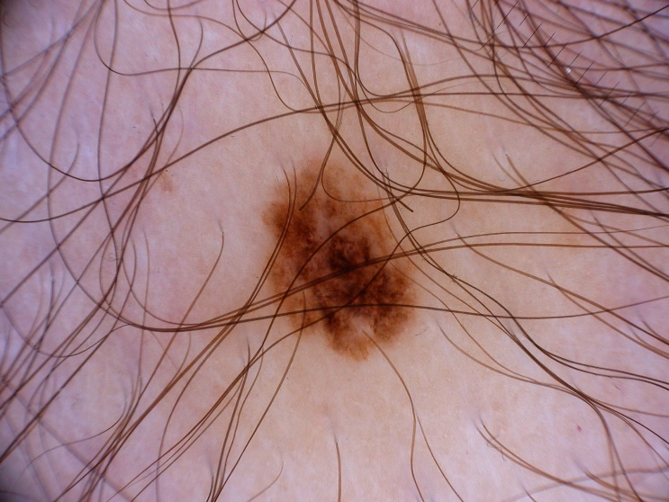

ISIC_95 DICE_SCORE 0 (number 33)



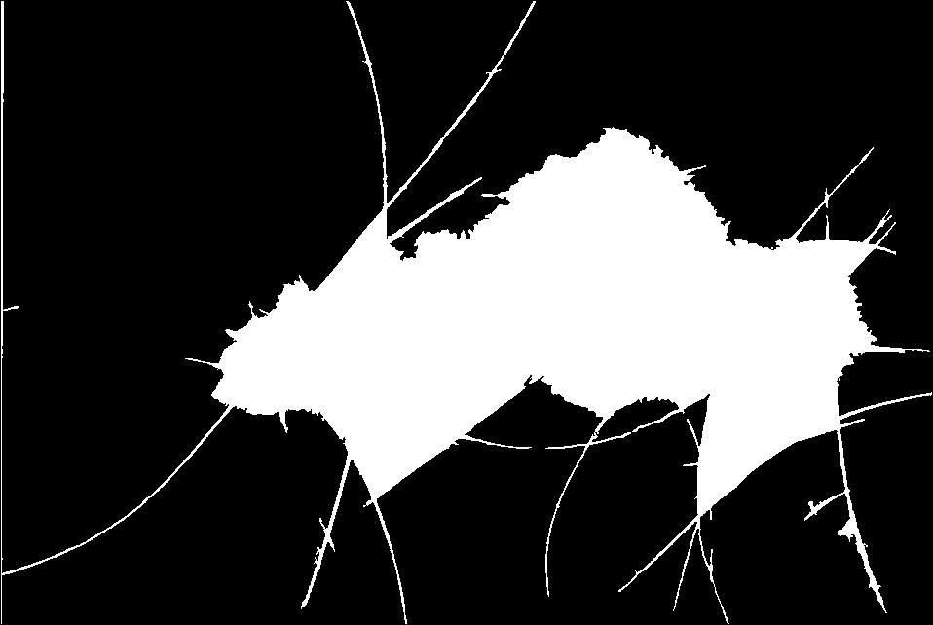



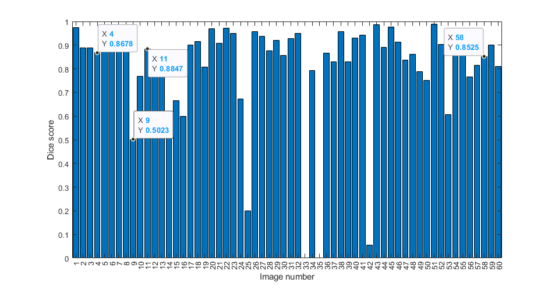

# Concept

To solve this task, I chose to use a Markov Decision Process via a python library called the MDPtoolbox [12]. A Markov decision process (MDP) is A Discrete-time stochastic control process. It is used to provide a mathematic framework for modelling decision making in situations where outcomes are partly random and partly under the control of a decision maker [8]. This means the control is stochastic which is the case for our AI’s actions as previously described. This was why I thought the MDP would be an effective solution to solving the maze task.

“The MDP relies on the notion of state (S), describing the current situation of the agent, action (A) affecting the dynamics of the process and reward (R), observed for each transition between states” [9]. With the knowledge of the stochastic decision process and the AI’s state at every time step, the MDP’s goal is the survival of the agent for as long as possible while collecting rewards. To solve this task, phrasing the task as an MDP problem thus means searching for a policy, in a set, which optimizes a performance criterion for the considered MDP. This policy is then used to direct the AI by giving it the best action for each state of the grid maze it is in [6].

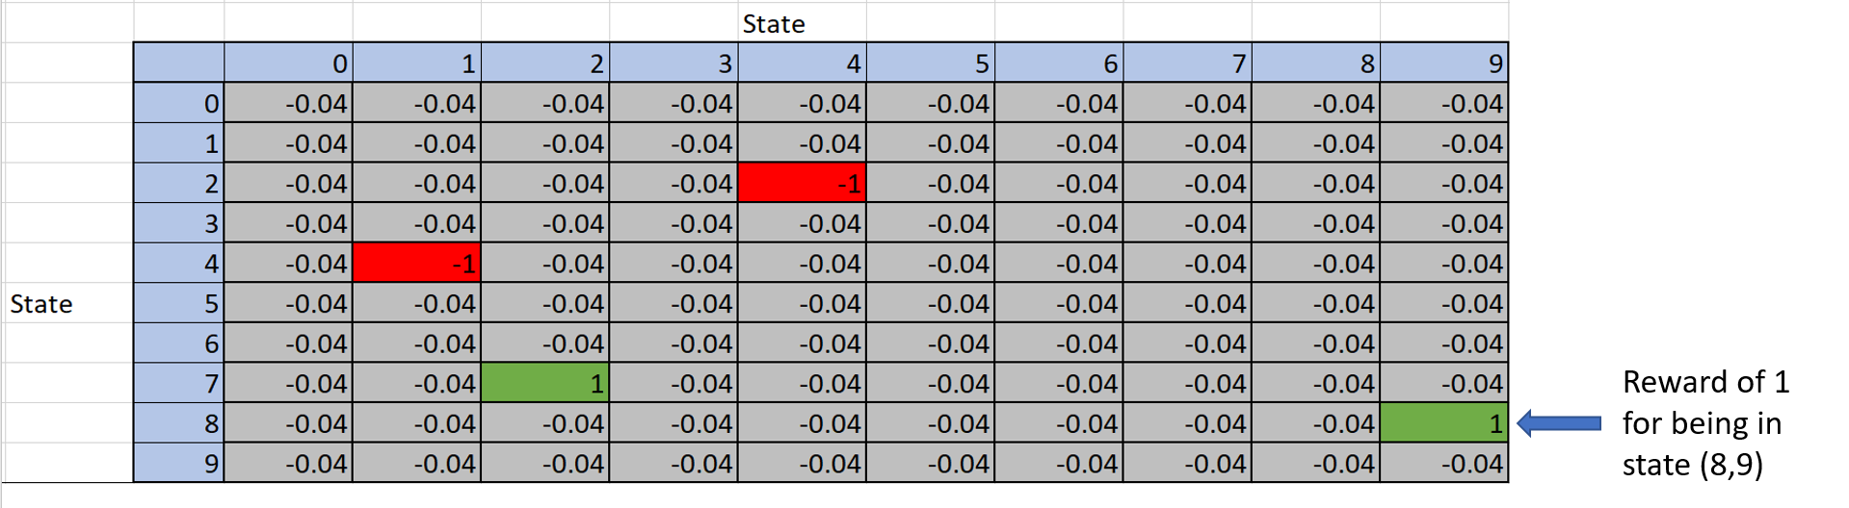

The example above is a replica of the reward matrix used in this research and illustrates that there are positive and negative rewards i.e., +1 and -1, for being in certain states of the grid such as the positive rewards in states (8, 9) and (7, 2). In non-terminal states, the reward is set as -0.04. By assuming that the utility of a run is the sum of the reward states, the -0.04 is an incentive for the AI to take fewer steps to get to the terminal state [11].

For the base grid of size 10 by 10 used in this project, the MDP requires as input, two matrices of data, one is a Probability matrix A.K.A transition model P (s’| s, a), of shape (A, S, S) where A are actions and S are states. This specifies an array of possible actions (A) for each state. Each S x S, then specifies the transition probabilities of reaching the second state by applying that action in the first state [6]. This meant the probability matrix would have been a (4,100,100) matrix because there were 4 possible actions the AI could take at any state.

The other, a reward matrix of shape (S, A) A.K.A reward function R(s), which specifies a set of S vectors equivalent to the S set of states, one for each state and each is a vector with one element for each of the actions. Each element, (also called the expected utility), is then the reward for executing the relevant action in the state. (This models the cost of actions) [6]. For a grid of size 10 by 10 the reward matrix was a (4,100) matrix, each column belonging to an action and each row, a state of the grid and within that state was the reward for being in said state.

The Probability and reward matrices can be generated recursively using the bellman equation [10] to compute the expected utilities for each state of the maze grid.

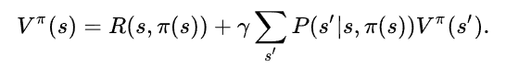

1. The Bellman Equation used to compute the probability value of each cell for a change of state by a given action

A policy much like:

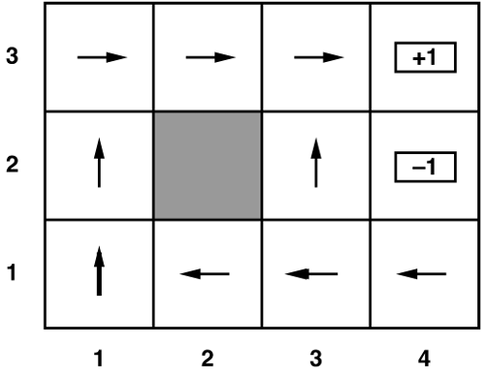

1. An example of a simplified policy that will be generated by the MDPtoolbox library from the Transition model and Rewards function.

is then generated from the two tables, and this then gets the best possible action in each state and returns that value as a command to the AI when it is in each of those states.

To generate the expected utility of each state I required a motion model:



1. A motion model to illustrate the stochastic nature of the AI’s actions

95% of the time the AI moved as intended and 0.5% of the time it moved perpendicular to the direction indented. Half the time to the left and half the time to the right.

To describe each action a transition model can be used and since the actions are stochastic, each can be described as:

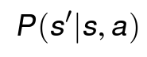

Where a is the action that takes the AI from s to s’. These transitions are assumed to be (first order) Markovian and therefore only take into consideration, the current and next states.

In a special case such as whenever the AI hit a wall, a “wall bouncing algorithm” had to be developed. This algorithm simply returned the probability of the action in the current state plus the probability of taking the action as the value of the current state.

As this research was divided into two solutions, one for a fully observable environment and another for a partially observable environment, the policy was only used whenever the AI had enough information to create a policy, i.e., the AI had to have seen at least one bonus, a meanie, and a pit. This meant the policy would be inactive a lot of the time in the partially observable scenario and instead the AI would have to use a greedy approach to find bonuses and avoid pits and meanies.

This method was chosen because it allowed the AI to dynamically switch between two states, one where it moved with a policy that told it the best action for any state the AI was in and another that allowed the AI to successfully navigate to bonuses whilst avoiding meanies and pits coming in and out of visibility limit.

# Evaluation

Surprisingly, the AI didn’t always perform better when the partially observable parameter was set to FALSE. This is evident because the MDP was not perfect and could not always provide a better policy to follow before too many obstacles were present as new meanies were added after a few time steps of the simulated world.

Three scenarios were created with varying amounts of bonuses, pits, arena sizes and speed of spawning meanies. For the sake of word count only the 10 by 10 grid will be analyzed in detail and the result tables in the appendix will show the results of the other tested parameters.

When partially visible was TRUE, the first scenario had a mean score of 14.6 and survival time of 9.6(s) and the second scenario which has double the parameters of the first scenario had a mean score of 26.5 and survival time of 21.4(s). Lastly, the 3rd scenario which yet again doubled the parameters had a mean score of 15.8 and survival time of 14.3(s).

In contrast, when partially visible was FALSE, the first scenario had a mean score of 15.6 and survival time of 11.2(s). The second scenario had a mean score of 16.9 with survival score 7.6 and lastly, the third scenario had a mean survival time of 19.7 and survival time of 10.3.

At the time of this test, this demonstrated that in most cases, a larger grid size led to longer survival times and a higher bonus. In smaller grid sizes the AI was getting caught more quickly, resulting in a lower score and survival time. Tables of results can be found below in the Appendix.

In conclusion, my method of generating a reward matrix via the bellman equation fell short because it recursively added each reward but only one at a time for the arrays of bonuses, pits, and meanies. I therefore had to create a priority queue whereby only the instances of each obstacle or reward closest to the AI at every time step would be added to the reward matrix and dealt with at each time step. This meant that when dealing with multiple meanies (Figure x) the AI could get caught with a pincer move because only the closest meanie chasing it would have a negative reward associated with it and thus it would not see another meanie coming from another direction until it was too late. In addition, this meant that the AI would not perceive obstacles as “close” if there was a meanie with coordinates closer to the AI than the adjacent obstacle

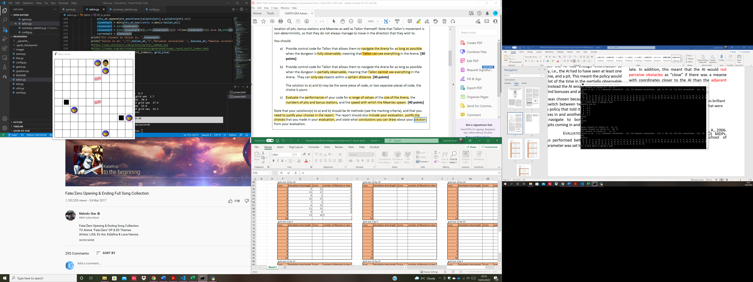

1. An image of the grid showing how Tallon can get trapped by multiple meanies. In this example the policy gave the best action for that state and got Tallon out to survive for longer.

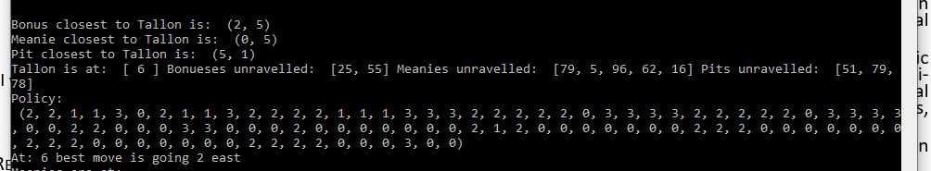

1. This shows the policy in Figure 4 and how Tallon interprets the closest obstacles.

This shows that although the meanies at (1,6) and (0,5) were equally close to Tallon if we look at the graph, Tallon still sees the closest Meanie as the one at (0,5) since Tallon is at (0,6) and this is dangerous because it means Tallon could have moved into the adjacent meanie at (1,6).

Suggestions for improvement include finding a way to add all current meanies, pits and bonuses into the reward function so the MDP library can create a better policy and making the code more programmer friendly.

##### Acknowledgment

I would like to acknowledge Simon Parsons for his brilliant teaching and for bringing to light, techniques that were applied to this project

##### References

1. Toussaint, M., Harmeling, S. and Storkey, A., 2006. Probabilistic inference for solving (PO) MDPs. Technical Report EDI-INF-RR-0934, School of Informatics, University of Edinburgh.
2. Korf, R.E., 1988. Optimal path-finding algorithms. In Search in artificial intelligence (pp. 223-267). Springer, New York, NY.
3. Lester, P., 2005. A* pathfinding for beginners. online]. GameDev WebSite. http://www. gamedev. net/reference/articles/article2003. asp (Acesso em 08/02/2009).
4. Goyal, A., Mogha, P., Luthra, R. and Sangwan, N., 2014. Path finding: A* or dijkstra's?. International Journal in IT & Engineering, 2(1), pp.1-15.
5. Qudrat-Ullah, H., Spector, J.M. and Davidsen, P. eds., 2007. Complex decision making: Theory and practice. Springer.
6. Simon Parsons, 2022. Lecture 7: Complex decision making. https://uol.cloud.panopto.eu/Panopto/Pages/Viewer.aspx?id=b69f615e-0f8f-45d0-9dcf-adef00962046
7. Florescu, I., 2014. Probability and stochastic processes. John Wiley & Sons.
8. Wikipedia, 2022. Markov decision process. https://en.wikipedia.org/wiki/Markov_decision_process
9. Garcia, F. and Rachelson, E., 2013. Markov decision processes. Markov Decision Processes in Artificial Intelligence, pp.1-38.
10. Peng, S., 1992. A generalized dynamic programming principle and Hamilton-Jacobi-Bellman equation. Stochastics: An International Journal of Probability and Stochastic Processes, 38(2), pp.119-134.
11. Simon Parsons, 2022. Lecture 9: Markov Decision Process. <https://uol.cloud.panopto.eu/Panopto/Pages/Viewer.aspx?id=6f0e8ec4-045d-401d-b4c1-adf600963e25>
12. Chadès, I., Chapron, G., Cros, M.J., Garcia, F. and Sabbadin, R., 2014. MDPtoolbox: a multi‐platform toolbox to solve stochastic dynamic programming problems. Ecography, 37(9), pp.916-920.

# Appendix

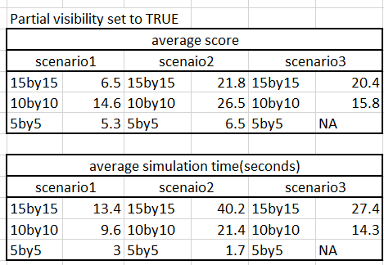

1. *This is an image of my stat table which shows Tallon’s performance when partial visibility was set to TRUE for 3 scenarios that are outlines in more detail in the images below*

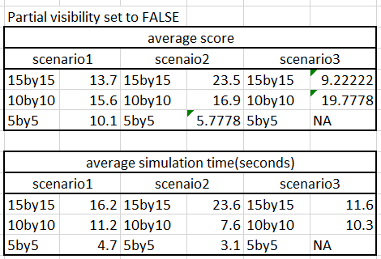

1. *This shows Tallon’s performance when partial visibility was set to FALSE for the 3 scenarios outlines in more detail in the images below*

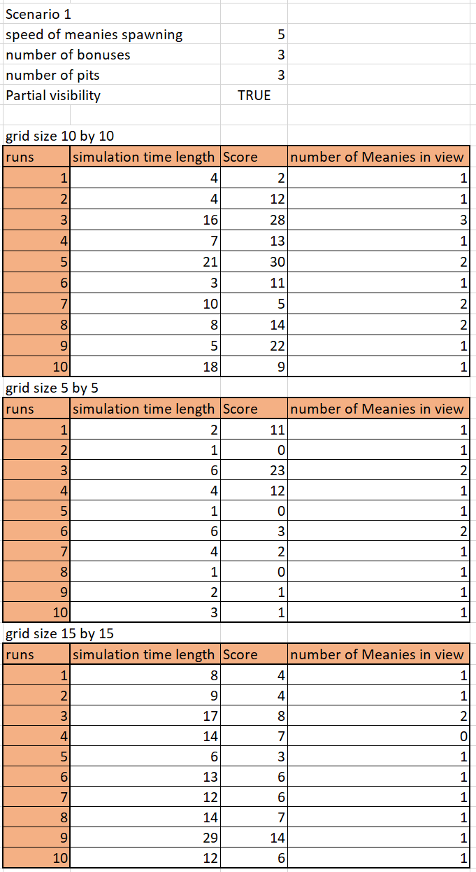

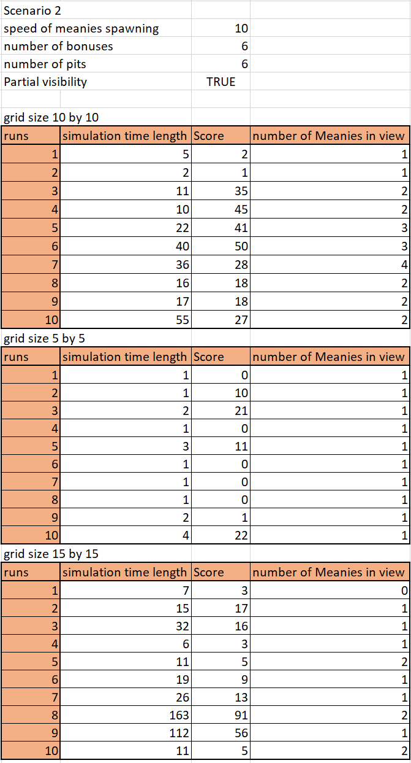

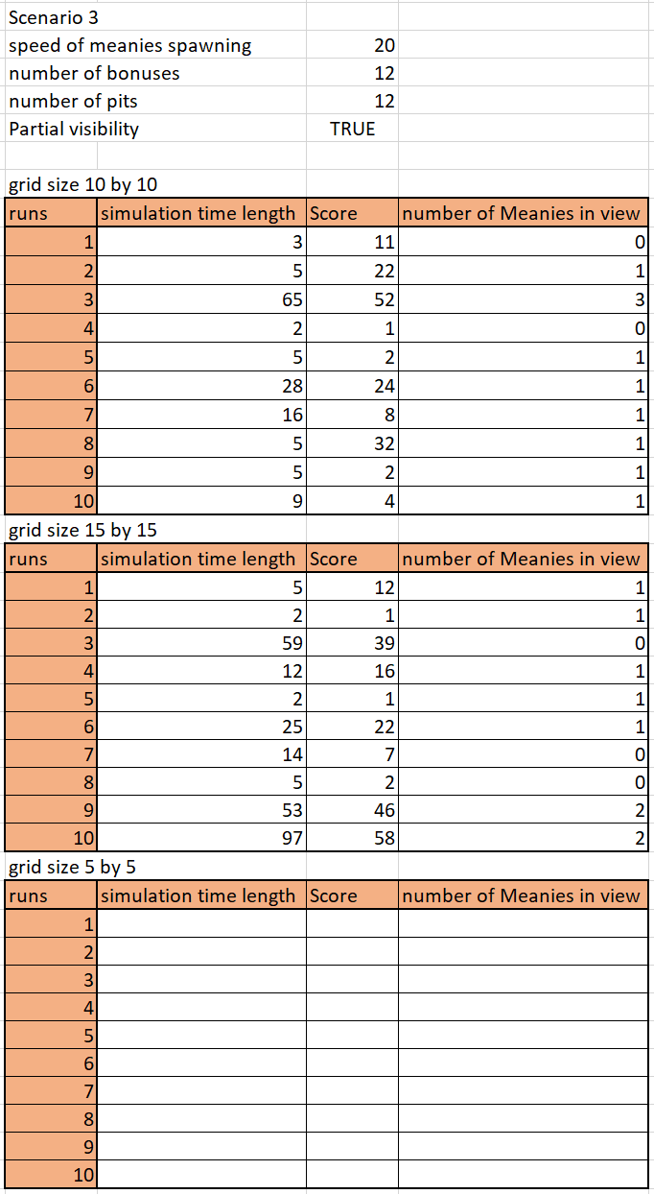

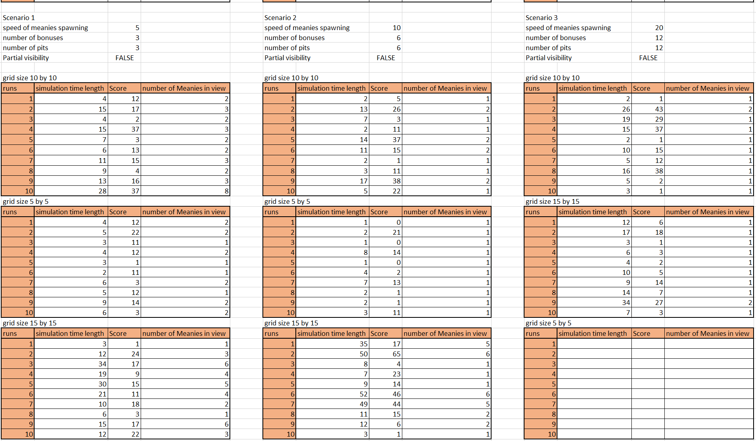

**

**

*The Third scenario does not test a 5 by 5 grid for either partial or full visibility because it is not possible to simulate this as the grid dimensions are too small to spawn in all the assets*

*Image of rewards function which shows that although there were two bonuses, two meanies and three pits all active, the rewards table only has one present at each time step, the closest one to Tallon is the only one present. This enables Tallon to get caught off guard by enemies or traps ahead of it when it is moving in the y axis.